RAFOS SECRETARY

2 Old Place
Aldwick
BOGNOR REGIS
West Sussex
PO21 3AU

Tel: 01243 920289

theknightsat2@gmail.com
rafos_secretary@hotmail.com
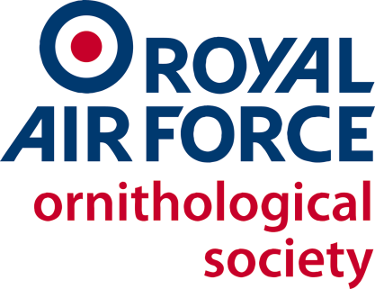

RAFOS/Sec/18

Dear RAFOS Member 6 August 2018

THE 53rd ANNUAL GENERAL MEETING OF THE ROYAL AIR FORCE ORNITHOLOGICAL SOCIETY ON SATURDAY 17 NOVEMBER 2018

It is my pleasure, on behalf of your Committee, to invite you to attend the 53rd Annual General Meeting of the Royal Air Force Ornithological Society. By kind permission of the Station Commander the meeting will be held on Saturday 17 November 2018 in the Officers’ Mess, RAF High Wycombe. HP14 4XW is the closest post code for your sat nav.

If you wish to attend or to have your apologies formally recorded, please complete the attached form and return it to me at the above address, with any payment, to arrive no later than Friday 26 October 2018. Due to administrative problems, I cannot accept payment on the day. Should you prefer to use e-mail, please download the equivalent form on the RAFOS web site, www.rafornithology.org.uk. The price for lunch is as last year. For those who wish to use internet banking the account is RAF Ornithological Society Treasurer’s Account, Account Number 01890688, Sort Code 30 93 48. Please e-mail me if you use this method so I can track who has paid.

If you are travelling by car, please provide me with details of your vehicle on the attached form or by e-mail using the form on the RAFOS website. If you are using public transport the 300 bus service runs between High Wycombe and Princes Risborough via Walter’s Ash and Naphill. Grimm’s Meadow is the nearest bus stop to the Officers’ Mess. Please note that the earliest arrival time is 11:00. Photo ID will be required at the gate; Service ID card, photo driving licence or passport is acceptable.

The AGM agenda will be issued on the day. Please let me have details of any items you wish to be added to the agenda as soon as possible and by Friday 26 October 2018 at the latest. If you are planning to enter the Art and Photography competition, please see the rules which are attached which describe the categories for the competition.

You are welcome to arrive any time from 11:00 onwards when tea and coffee will be available. Those entering the Art and Photography competition may do so on the day, but must submit their entries by 11:30. Parking is at the Officers’ Mess car park. Wheelchair access is available. Lunch will be available from 12:00. The speaker will start at 13:00. Sacha Dench will talk about her journey following the migration route of Bewick’s Swans from Russia. The formal AGM will follow this talk.

The following committee positions are due for election at this meeting:

Chairman.
Treasurer
FALO.
Ringing Co-ordinator.
Journal Editor.
Web Administrator.
Production Manager.
Publicity Member.

If you wish to volunteer for any of these positions please let me know. We welcome new members to the Committee.

In the evening there will be a gathering at The Thatch public house, 29-30 High Street, Thame, OX9 2AA (pay as you dine).

I regret that there is no on-base accommodation available. In the area there are, among others (found by internet search, not by any recommendation):

- Travelodge, Thame, OX9 3SB.
- Travelodge, High Wycombe, HP11 2DQ.
- Premier Inn, High Wycombe, HP13 5HL.
- Premier Inn, Beaconsfield, HP10 9YL.
- The George and Dragon Hotel, High Wycombe, HP14 3AB.
- The Clifton Lodge Hotel, High Wycombe, HP12 3AR.
- Holiday Inn, High Wycombe, HP11 1 TL.

Should you have any queries concerning the AGM, please contact me. I look forward to meeting you.

Jan Knight
J M KNIGHT
Mrs
RAFOS Secretary

