ANNEX D TO
RAFOS/SEC/18
DATED 24 NOV 18

FALO’S REPORT

2018 Programme

The 2018 Field Activities programme is now almost complete, with the major news being that the JNCC Seabirds Census finally took place after 2 years of DEFRA/JNCC wrangling over funding.

- Slimbridge Outing. Led by Bill Francis and attended by 15 members, on 7th January. A good turn out on a cold beautiful day with lots of great birding.

- Expedition WINTER DUCK (WD) 2018. Led by Martin Routledge and attended by 13 members, split into 3 separate teams, covered 219 WeBS sites from an allocated 226, with 7 sites uncovered due to weather and access problems. Additionally, 61 BTO BirdTrack species lists (at the 10 Km square level) were completed. Ruff and little gull sightings were the 1st and 2nd respectively for Exped WD, with 2 of the latter sightings. The results of this year’s survey were hand-delivered to BTO WeBS’ staff on 6 Apr18.

- Expedition ISLAY MIST 2018. Another successful Islay spring foray, led by the Knight team, with 9 participants (including 1 Islay virgin), enjoyed generally good weather with 118 species recorded. Of particular note, curlew and hen harrier breeding surveys were conducted for the RSPB as were surveys of Islay Airport environs to provide data for an update to the Wildlife Management Annex of the Airport Manual.

- Bird Fair and Catterick. Several members attended the Bird Fair, but no Catterick ringing event took place.

- Expedition SIMMER DIM (SD) 2018. Led by Keith Cowieson and with 12 participants (including 2 new members), split into 2 teams, covered 103 Seabird Monitoring Programme (SMP) sites from an allocated 107, on the northern Orkney islands of Eday and Stronsay, with 2 new sites covered and now added to the SMP database. Four outlying island sites were not covered due to lack of time and resources. Additionally, 15 species lists for BirdTrack at the 10 Km square level were completed, with a total of 589 BirdTrack records created for the survey area with 74 species recorded. Meanwhile, 1 British Birds Rarities Committee Rarity Submission was raised – snowy owl, individual nest and colony nest record cards covering 25 species are in the process of being generated for the BTO Nest Record Scheme, 14 individual birds from 5 species were ringed on Stronsay, 2 Nest Incorporation of Plastic Monitoring Form were generated, a hedgehog sighting on Eday was forwarded to Scottish Natural Heritage and the Orkney Mammals Recorder and 3 Pollinator Monitoring Scheme, Flower Insect Timed (FIT) count records were submitted to the Centre for Ecology and Hydrology FIT database. Expedition costs were defrayed by £2250 of external grants, from the Seabird Group and RNBWS. £550 was returned to benefactors due to underspending on small boat hire and fuel. Post-expedition ‘Grant’ article written for the Seabird Group Newsletter (SGN) and published in SGN 139 in October 2018.

- Forthcoming Events. There are no further official Society field activities planned. A post-AGM Field Meeting could take place if someone is prepared to organise one. Otmoor or Little Marlow gravel pits would be possibilities. No winter Somerset Levels event envisaged at this stage as experience suggests that it is likely to be less productive than a spring visit, although I’m told discussion on this continues.

- Summary of 2018 Programme (to date).

2018 | Date | Venue | Leaders | Activity | Sponsored | Attendees
1 | 7 Jan | WWT Slimbridge | Bill Francis | Wetland Centre Tour | No bid | 15
2 | 4-12 Feb | Winter Duck 18 | Martin Routledge | WeBS | £1100 | 13
3 | TBC Mar-Apr | Somerset Levels | Pete Evans et al | Field meeting | No bid | Cancelled, cannot run concurrently with Islay Mist
4 | 12-19 May | Islay Mist | Team Knight | Field meeting | £250 | 9
5 | 18-29 Jun | Orkney | Keith Cowieson | JNCC Seabirds Census | £850 | 12
6 | 17 Aug | Bird Fair/Catterick | Julia Springett | Ringing experience | No bid | Did not take place this year
7 | 17 Nov | TBD | TBD | Post-AGM Field meeting | No bid | Only if volunteer found
8 | TBC Dec | Somerset Levels/Norfolk | Pete Evans | Field meeting | No bid | Cancelled
 | Total  (to date) |  |  |  | £2200 | 49

Note: 2018 was not an ‘overseas expedition’ year, so funding allocation normally a maximum of £2000.

Proposed 2019 Programme.

First stab below – settling into the recent pattern of fewer but arguably higher quality, more scientifically-focussed events. Last year of JNCC Seabirds Count, and they have proposed that we assist in surveying under-counted areas in the north and west of Mainland Shetland - highlighted – initial scoping and planning underway. RNBWS interested in some level of collaboration – dialogue underway.

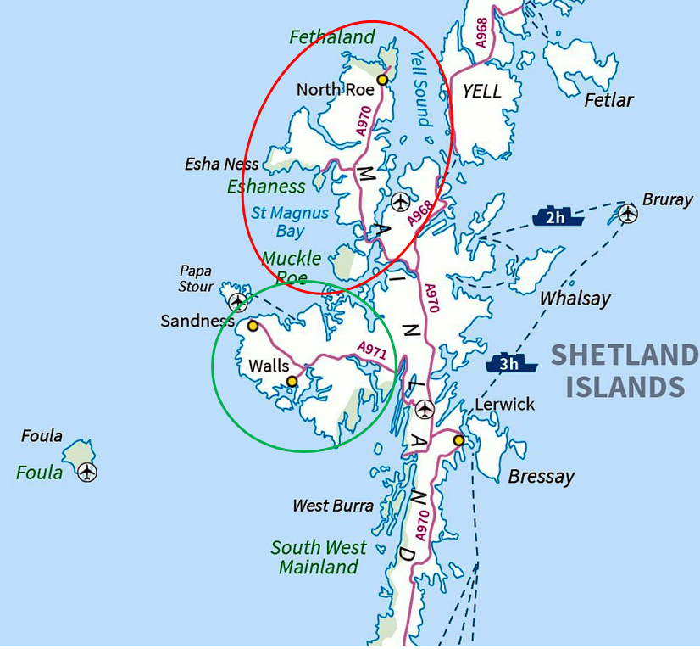

2019 | Date | Venue | Leaders | Activity | Sponsored
1 | 6 Jan | WWT Slimbridge | Bill Francis | Wetland Centre Tour | No bid
2 | 25 Jan - 2 Feb | Winter Duck 19 | Martin Routledge | WeBS | £1100
3 | 31 May – 2 Jun | Somerset Levels | Pete Evans, Earnshaws & Knights | Field meeting | No bid
4 | Mid-late Jun | Mainland Shetland | Keith Cowieson | JNCC Seabird Census | £1000 (assumes grant received from Seabird Group)
5 | TBD Sep/Oct | Gibraltar | Julia Springett | Joint service ringing exped | ~£250
6 | 26 Oct-2 Nov | Islay Mist | Team Knight | Field meeting | ~£250
7 | Nov | TBD | TBD | Post-AGM Field meeting | No bid
 |  |  |  |  | ~£2600

Note: 2019 is an ‘overseas expedition’ year, so the funding allocation is normally around £2500.

Proposed 2020+ Programme.

- Revisit 2007-11 BTO Bird Atlas country. A proposal to revisit the areas covered during BTO Bird Atlas surveying 10 years on. Venues could include the Kintyre peninsula in Scotland and East Anglia.

- All and any other ‘Good Ideas’ gratefully accepted.
  - Leaders & organisers required.
  - Volunteers gratefully accepted.

Keith Cowieson
FALO

